Chewing Strength Measurement Devices
Most commonly used device for measurement of fruit hardness is fruit penetrometer.
Function:
GY Series produce fruit penetrometer with 3 models: GY-1, GY-2, GY-3, which special for inspecting the hardness of the fruits, such as apple, pear, strawberry, grape and so on.
Application: (Head Dimension)
3.5mm is used for testing soft fruits, such as apple, pear, strawberries and grapes.
8mm is used for testing a little hard fruits, such as cantaloupe.
11mm is used for testing the hard fruits, such as pawpaw, immature apple.
Model | GY-1 | GY-2 | GY-3
Range | 2-15kg/ cm² | 0.5-4kg/ cm² | 0.5-12kg/ cm² | 1-24kg/ cm²
 | (×10 5pa) | (×10 5pa) | (×10 5pa) | (×10 5pa)
Head Dim: | Φ3.5mm | Φ3.5mm | Φ8mm | Φ11mm
Resolution: | 0.1 | 0.02 | 0.1 | 0.2
Stoke | 10mm
Dimension | 140*60*30mm
Weight | 0.5kgs

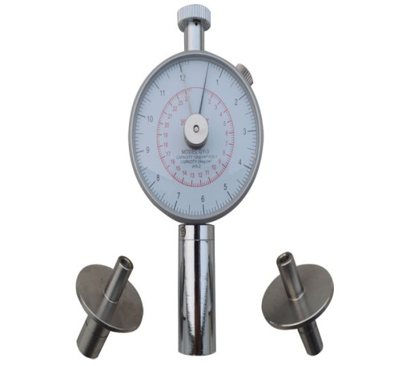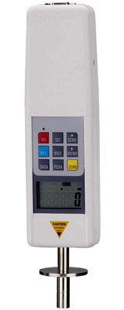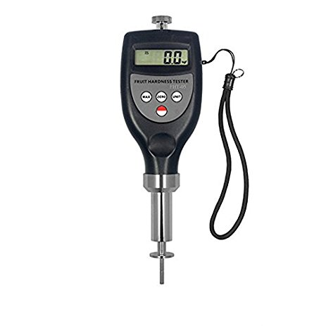
FHT-05, FHT-1122
GY-4
GY-3

Model | Head Dim | Price | Link
GY-1 | 3.5mm | 58$ | https://www.amazon.com/VETUS-INSTRUMENTS-Penetrometer-Sclerometer-durometer/dp/B06XGD7H3S/ref=sr_1_2?ie=UTF8&qid=1516208807&sr=8-2&keywords=GY-1+fruit+penetrometer
GY-2 | 3.5mm | 61$ | https://www.amazon.com/CNYST-Penetrometer-Portable-Hardness-Sclerometer/dp/B076CGNXJ8/ref=sr_1_2?s=sports-and-fitness&ie=UTF8&qid=1516209284&sr=8-2&keywords=GY-2+penetrometer
GY-3 | 8mm and 11mm | 63$ | https://www.amazon.com/CNYST-Portable-Hardness-Penetrometer-Measuring/dp/B076CLKJV6/ref=sr_1_4?ie=UTF8&qid=1516208807&sr=8-4&keywords=GY-1+fruit+penetrometer
GY-4 (Digital) | 3.5mm, 8mm and 11mm | 150$ | https://www.ebay.com/itm/New-GY-4-Fruit-Hardness-Tester-Digital-Fruit-Penetrometer-Sclerometer-Testing-/282446685580?_trksid=p2385738.m4383.l4275.c10&var=581590220645
FHT-05 Portable Fruit Hardness Tester | 3.5mm | 223$ | https://www.amazon.com/CNYST-Portable-Hardness-Sclerometer-Penetrometer/dp/B0769KN1RT/ref=sr_1_fkmr0_4?s=industrial&ie=UTF8&qid=1516210184&sr=1-4-fkmr0&keywords=SRFH-1122+Fruit+Hardness+Tester
FHT-1122 Fruit Hardness Tester | 7.9mm and 11.1mm | 240$ | https://www.ebay.com/itm/FHT-1122-Fruit-Hardness-Tester-Handheld-Durometer-Penetrometer-for-Fruit/253198808806?hash=item3af3d336e6:g:6i4AAOSwQlRZyfLa

